Muhammad Zafitra B. Yaakub
148, Jalan SG9/1, Taman Sri Gombak,
68100, Batu Caves, Selangor
014-5263817
zafit_ra@yahoo.com
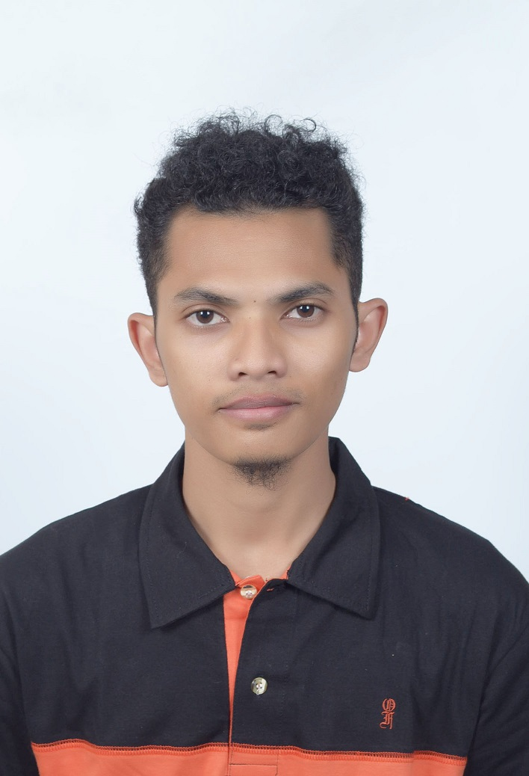

Contact Info
Personal Particulars
Age : 24 years
Date of Birth : 10 April 1991
Nationality : Malaysian
Race : Malay
Gender : Male
Marital Status : Single
IC No. : 910410-02-5343
Educational Background

Highest Education
Field of Study : Mechatronic Engineering
Qualification : Degree
Institute/University : International Islamic University Malaysia (IIUM)
CGPA : 2.9
Graduation Date : 1/11/2015

Job Application
Position applied : Engineer

Course Taken

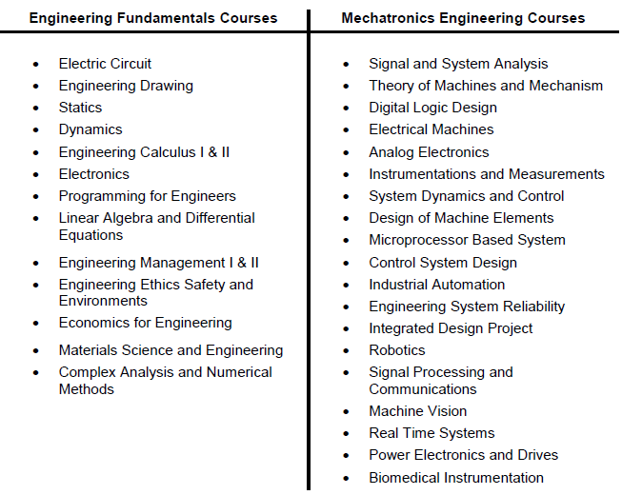

Skill

No | Software Skills | Level
1 | Microsoft Office | Advance
2 | MATLAB | Intermediate
3 | Pspice | Intermediate
4 | C/C++ Language | Intermediate
5 | Alibre Design (CAD Software) | Intermediate
6 | Eagle | Basic
7 | Easy 68k | Basic
8 | SCATS | Intermediate
9 | NEMO | Advance

Languages
(Proficiency: 0=Poor - 10=Excellent)

Language | Spoken | Written
Bahasa Malaysia | 10 | 10
English | 8 | 8

Miscellaneous
Expected Monthly Salary : RM 2300 (Negotiable)
Notice period : Immediately
Willing to Travel : Accordingly
Possess Own Transport : Yes
Licence Driving Class : B2, D
Certificate : AutoCAD , Microsoft Excel

Additional Info
WORKING EXPERIENCE:
- Internship at Turbine Technique Sdn Bhd
(June 2014 – August 2014)
- Attending a seminar for telecommunication line.
- Work as DT Engineer in VIP Complaint team that deal with VIP
(August 2015 – January 2016)
Task handle:
- DT for SMART LTE Project
- PLO Team
- Team in Jom Heboh Carnival
- Job team for Network team for ASEAN SUMMIT
- IBC (SMART Tunnel,IOI mall, KLCC and etc)
- Part of Team for Network Problem for Persidangan Agung Umno)
- Netzoom Project for Celcom worker complaints
- Part of team stand by for KLCC conference
- Attending seminar for Autocad Certificate
- Attending seminar for Microsoft Excel Certificate

STRENGTH:
- Able to do and learn any tasks related with
mechatronic engineering field.
- Able to communicate with others.
- Ready to learn and work in any new field of jobs.
- Ready to work independently with less guidance.
- Self motivated and have strong commitment of responsibilities.
- Fast learner
- Ready to work in a team

References

Name : Mohd Khairulzain Abd Rahman

Position : Senior Assistant Director
Centre for University Social Responsibility
International Islamic University Malaysia

Relationship : Lecturer

Contact : 03-61964109

